# Linkage of EMPIRE to the openENTRANCE Platform

Still missing: Uploading IAMC has been a "manual" process of checking the nomenclature for any relevant parameter/variable in EMPIRE on GitHub.com.

Code and data available at: <https://github.com/openENTRANCE/linkages/tree/main/EMPIRE>

## Workflow

### IAMC Input:  Utilizing input from other models in EMPIRE

step 1A) download data from GENeSYS-MOD (or any other model) from the IAMC platform.

step 1B) open GENeSYS-MOD data in MS Excel.

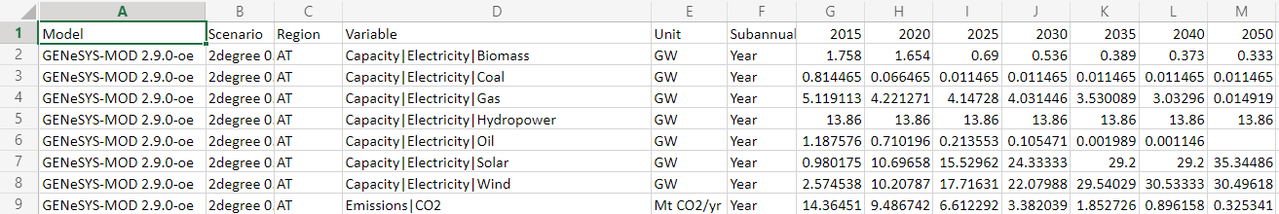

step 1C) filtering for the relevant data in MS Excel (e.g. CO2 emission in a specific country subject to one of the scenarios).

step 1D) copy+paste from GENeSYS-MOD IAMC xlsx-file to EMPIRE xlsx-file.

### Uploading IAMC: Uploading EMPIRE results to the IAMC platform

step 2A) checking the nomenclature for any relevant parameter/variable in EMPIRE on GitHub.com. The standardized IAMC print is a module that can be activated in the 'run.py' script of EMPIRE:



This will make EMPIRE perform its old print in addition to the IAMC print. Using dictionaries for countries and generators, EMPIRE nomenclature is converted to IAMC standard nomenclature.

step 2B) run the script that is already documented on the repo to write the EMPIRE IAMC .xlsx-file. All results are then appended row by row to a pandas DataFrame according to the IAMC format and finally printed/saved as a .csv-file.

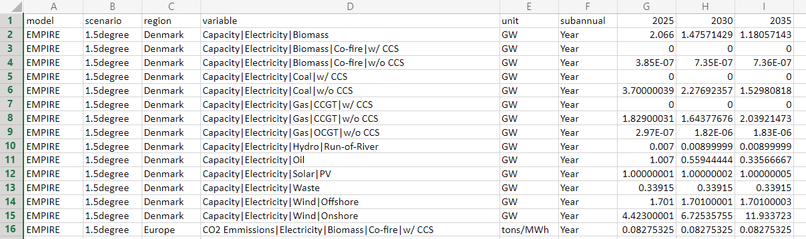

step 2C) upload the EMPIRE IAMC .xlsx-file to the scenario platform through the website.